Data Preprocessing and Cleaning Enhancements
Data Quality Assessment
The dataset was evaluated for completeness, consistency, and structural integrity across both tables: menu list and order details.
The menu list table contained a fixed number of records with no missing values in key fields such as menu item ID, item name, category, and price.
The order details table initially contained missing values in the item_id column. These missing entries were identified as data gaps within transactional records rather than independent observations. No duplicate records were found after validation.
Data type inconsistencies were observed, particularly in date and item identifier fields, which were standardized during preprocessing. Referential integrity between the menu list and order details tables was ensured through proper alignment of menu_item_id and item_id.

Data modelling: 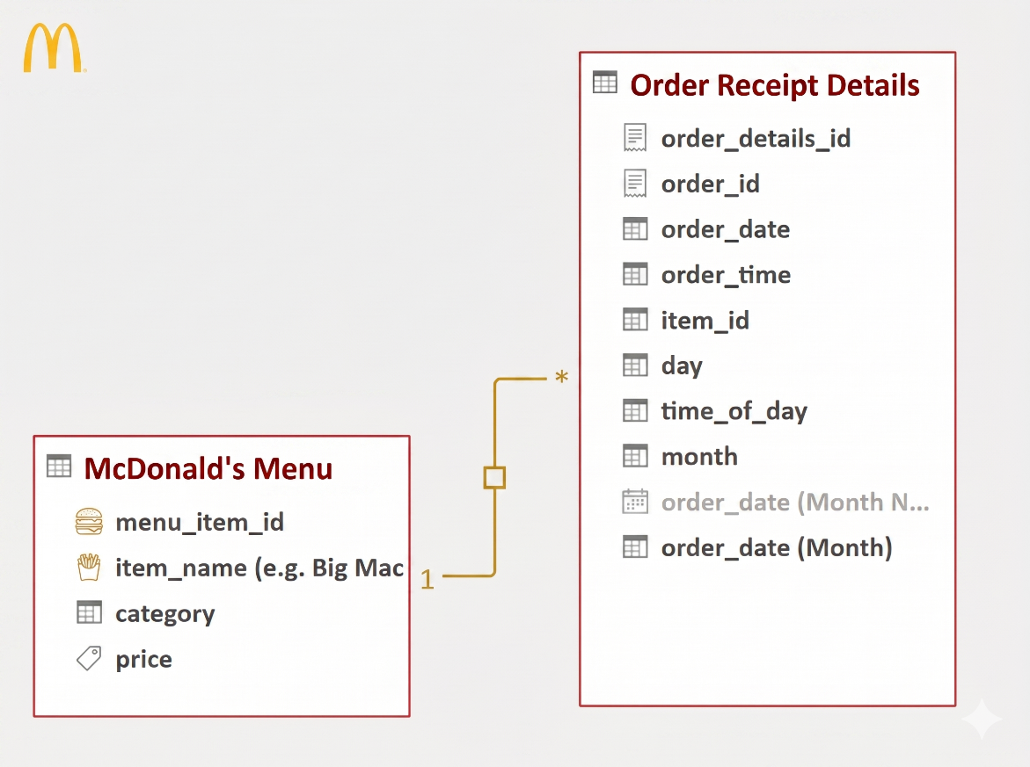

Handling Missing and Inconsistent Values
Missing values in the item_id column were handled using forward fill (Fill Down) to maintain continuity within transactional sequences. This approach preserved all records and ensured that no sales data was lost.
Rows containing invalid or erroneous date values were removed to maintain accuracy in time-based analysis. All remaining records were verified to contain valid and consistent values.

Data Transformation and Standardization
Column names were standardized and headers were promoted for both datasets. Data types were corrected to ensure compatibility with analytical operations:
- Numeric fields such as menu_item_id, order_id, and price were converted to appropriate numeric formats.
- Date and time fields (order_date, order_time) were converted to proper date and time data types.
- Text fields such as item name and category were standardized for consistency.
Unnecessary or redundant columns were removed where applicable to improve model efficiency and reduce clutter.

Feature Engineering (Derived Columns)
Several derived columns were created to enhance analytical capabilities:
- Time of Day: Orders were categorized into Morning, Afternoon, Evening, and Night based on order time.
- Day Name: Extracted from the order date to support weekday-level analysis.
- Month: Extracted from the order date to enable monthly trend analysis.
- Day Type: Classified records into Weekday and Weekend based on the day of the week.
These features support time-based segmentation and behavioral analysis of customer activity.

Data Integration and Enrichment
Instead of physically merging datasets, a relational approach was adopted. The order details table was linked with the menu list table using a one-to-many relationship:
- menu_list[menu_item_id] → order_details[item_id]
This structure allowed enrichment of transactional data with product attributes such as category and price while maintaining a clean and efficient data model.

Data Model Optimization
The dataset was structured into a simple analytical model:
- Fact Table: Order Details (transaction-level data)
- Dimension Table: Menu List (product-level data)
This structure supports efficient aggregation and enables accurate calculation of key performance metrics such as total revenue and item frequency.

Preprocessing Challenges and Improvements
During preprocessing, handling missing item_id values was a key challenge. Initial attempts involved removing null records, which led to discrepancies in total revenue calculations. This was later corrected by applying forward fill, ensuring data completeness and accurate aggregation.
Additionally, multiple iterations were required to standardize time-based columns and ensure correct categorization of time-of-day segments.

Assumptions Made During Preprocessing
- Missing item_id values belong to the same order sequence and can be accurately filled using adjacent records.
- All menu item IDs correspond to valid entries in the menu list table.
- Time-of-day segmentation thresholds adequately represent customer behavior patterns.
- Removal of erroneous date records does not significantly impact overall analysis.

Summary
The preprocessing and cleaning process ensured that the dataset is accurate, consistent, and analysis-ready. Missing values were handled without data loss, data types were standardized, and meaningful features were created to support deeper analysis.
The final structured dataset enables reliable calculation of key metrics and supports the development of an efficient and interactive dashboard.

DASHBOARD:
